**Manual for Particle motion analysis (PMA) using P-wave particle motions**

These are steps to perform Particle Motion Analysis using the grid-search algorithm. Based on the theory/derivation for using particle motions of P-waves and its coda (Park et al. 2018), the grid-search algorithm is a relatively robust technique that will estimate shallow shear-wave velocity.

**Step 1: P-wave picking**

Script: Template_correlation.sh (bash script)

The script picks P-arrivals based on a template.   
**Note: Check if SAC is installed.**

Input files: SAC files (e.g., data saved as .z/.r/.t/.sac)

Output files: saved as sac files appended with “picked”

No changes to the script are necessary except for updating the event directories, which may vary depending on how your data is organized.

Output files contain header information with updated P-arrivals as T1.  
  
Below is a snapshot of the a few lines of the script:

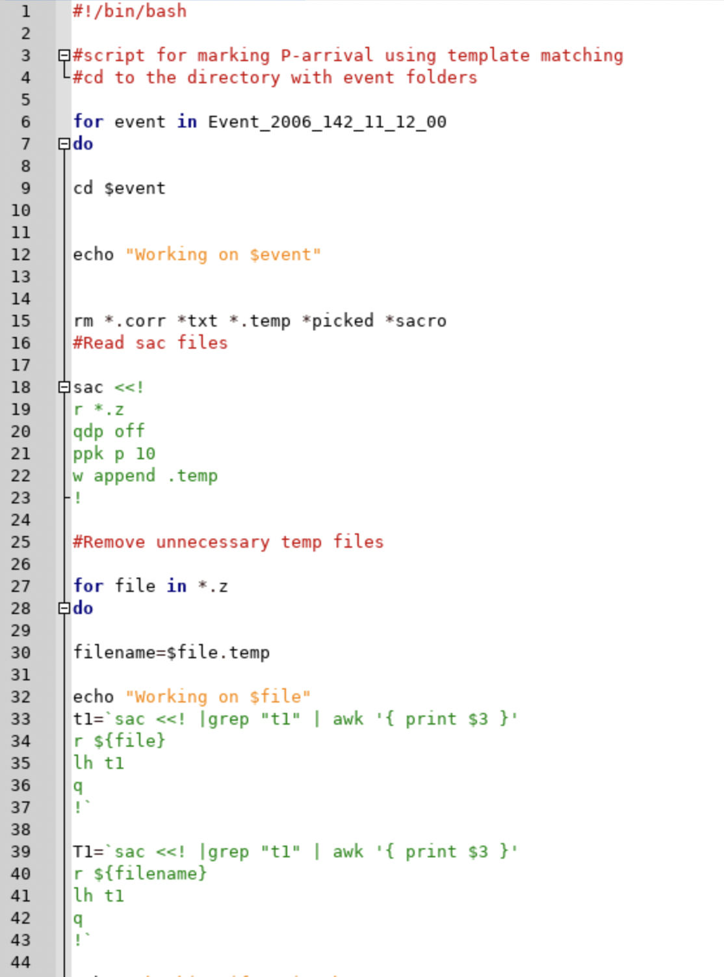

**Next steps will be in MATLAB. Check if MATLAB is installed.**

**Step 2: Run particle motion analysis**

Script: Sunnymethod_twin.m

Other functions required: natsort.m, natsortfiles.m, read_sacfiles_string.m, time_taper.m. **These functions do not need to be changed.**

The script reads the “picked” sac files and runs the grid-search algorithm to estimate Vs. The script also calculates the dominant frequency of the waveform.

Before running the script, create a “RESULTS” folder in the current directory to save the results. Inside RESULTS, create Twin_1 (currently it is Twin_1 since we are using twin = 1) and inside this create GRID_PLOTS and FREQ_PLOTS for saving output figures. Also create an “events.txt” file containing all the event filenames.

Snapshot of how the event.txt file should look like:

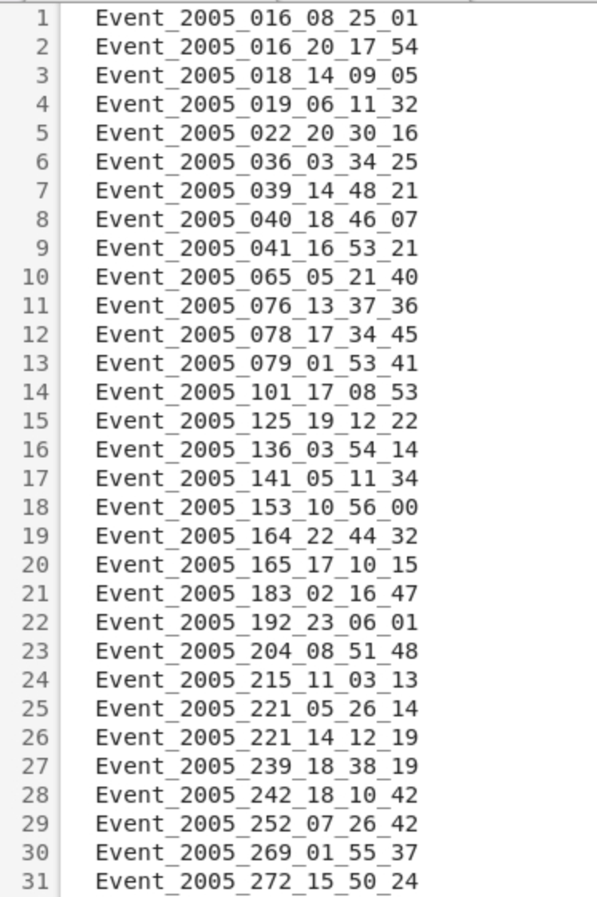

Input file: sac files with filename appended with “picked” (Output files from Step1).

Output file: Vs_solns saved as station_Vs_freq_results.mat.

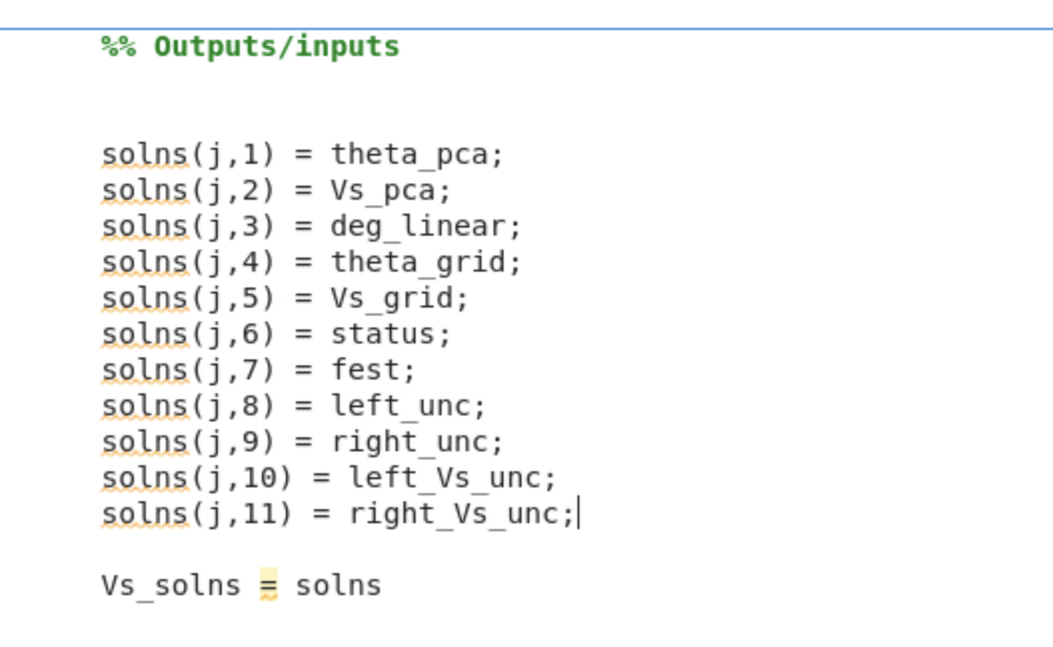

Changes to be made:  
Line 25 & 28 – path to event directory

**Parameters that can be changed:**

* twin – Time window to analyze. Currently set to 1 i.e., 1 second after P-wave onset.
* Range of search angles, theta (line 124) – change accordingly to match ray parameters of data and realistic Vs values.
* Quality measure: currently set to -20. Depending on where the minimum misfit is, this bound can be changed

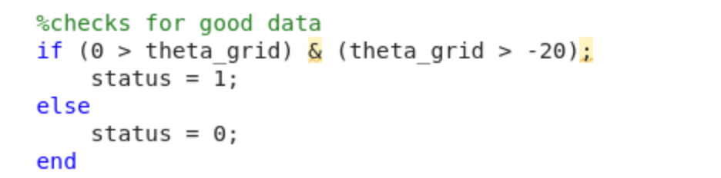

**Output plots:**

Figure 1 Figure 2

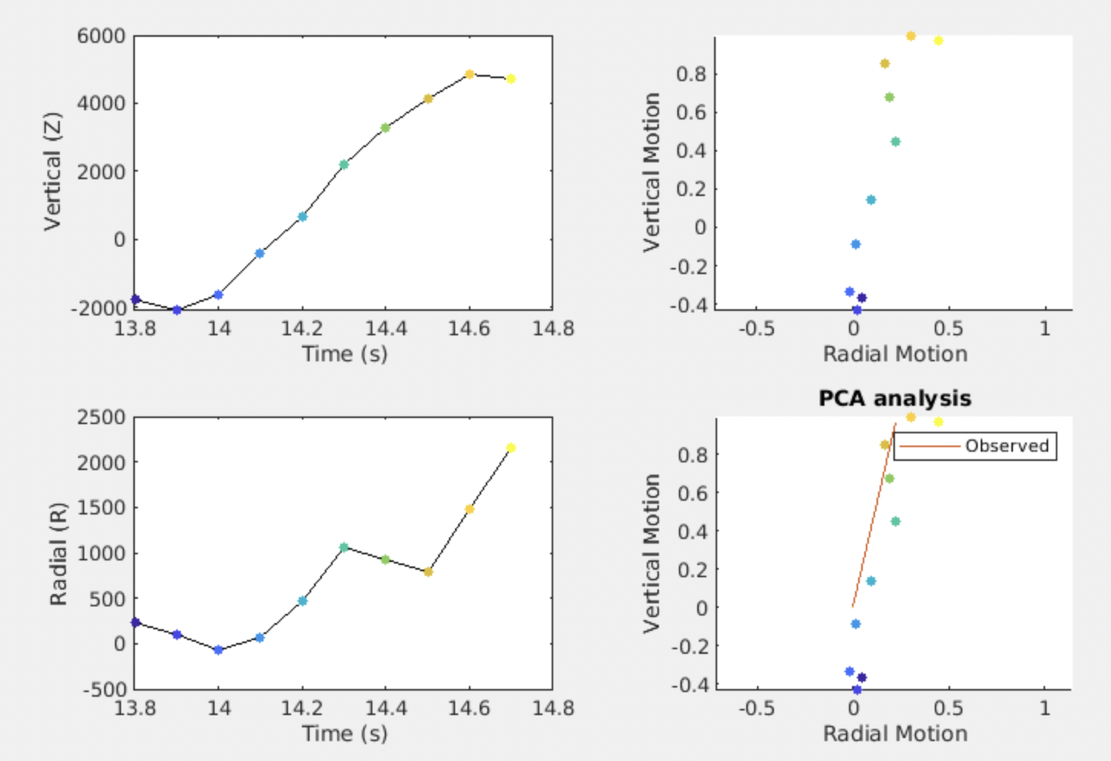 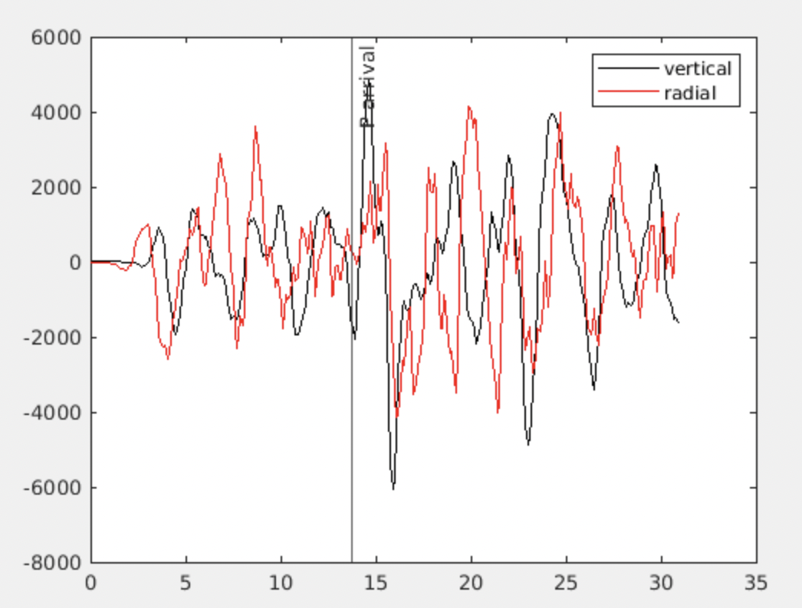

Figure3

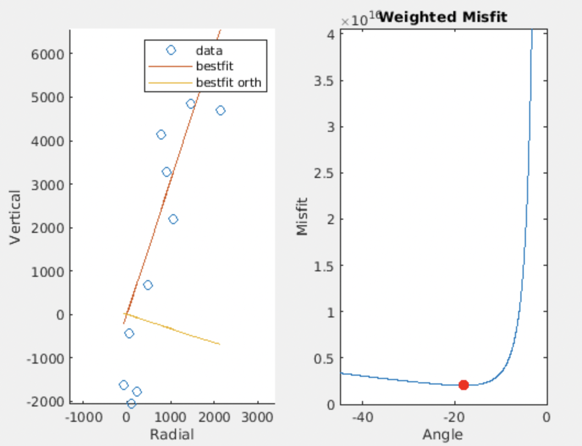

**Step 3 – Topographic slope calculation**

**Create another directory TOPO to save all results related to topographic corrections.**

Scripts – DEM_elevation.m and Topographic_slope_calc.m

Download DEM data: <https://search.earthdata.nasa.gov/search> and save them in a folder DEM.

DEM_elevation.m converts elevation data from .hgt format to readable format (.mat files). Topographic_slope_calc.m calculates the topographic slope (strike, dip, dip) around the stations.

**Step 3a: Run DEM_elevation.m**

Input files: DEMS in .hgt format

Output files: DATA_deg.mat and DATA_utm.mat

Required functions: deg2utm.m

Change path to DEM data

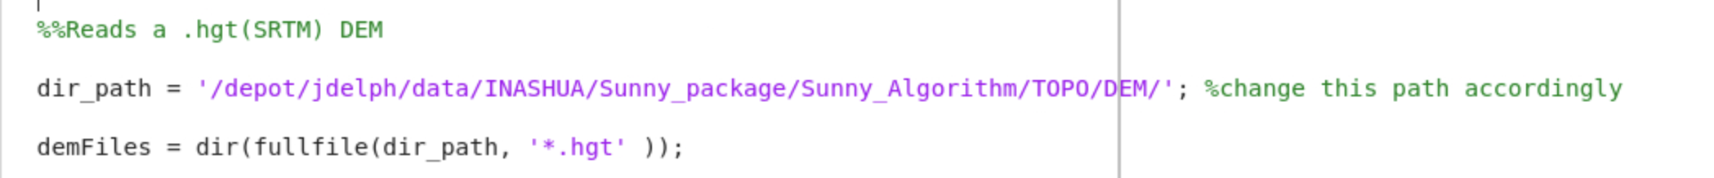

Change Line 26 (resolution_arcseconds) depending on the type of DEM data



**Step 3b: Run Topographic_slope_calc.m**

Input files: results.txt (text file containing filenames of output from Step 2), output files from Step 3a.

Changes to be made:

Line 15 – path to Twin_1

Line 32 – path to TOPO

results.txt:

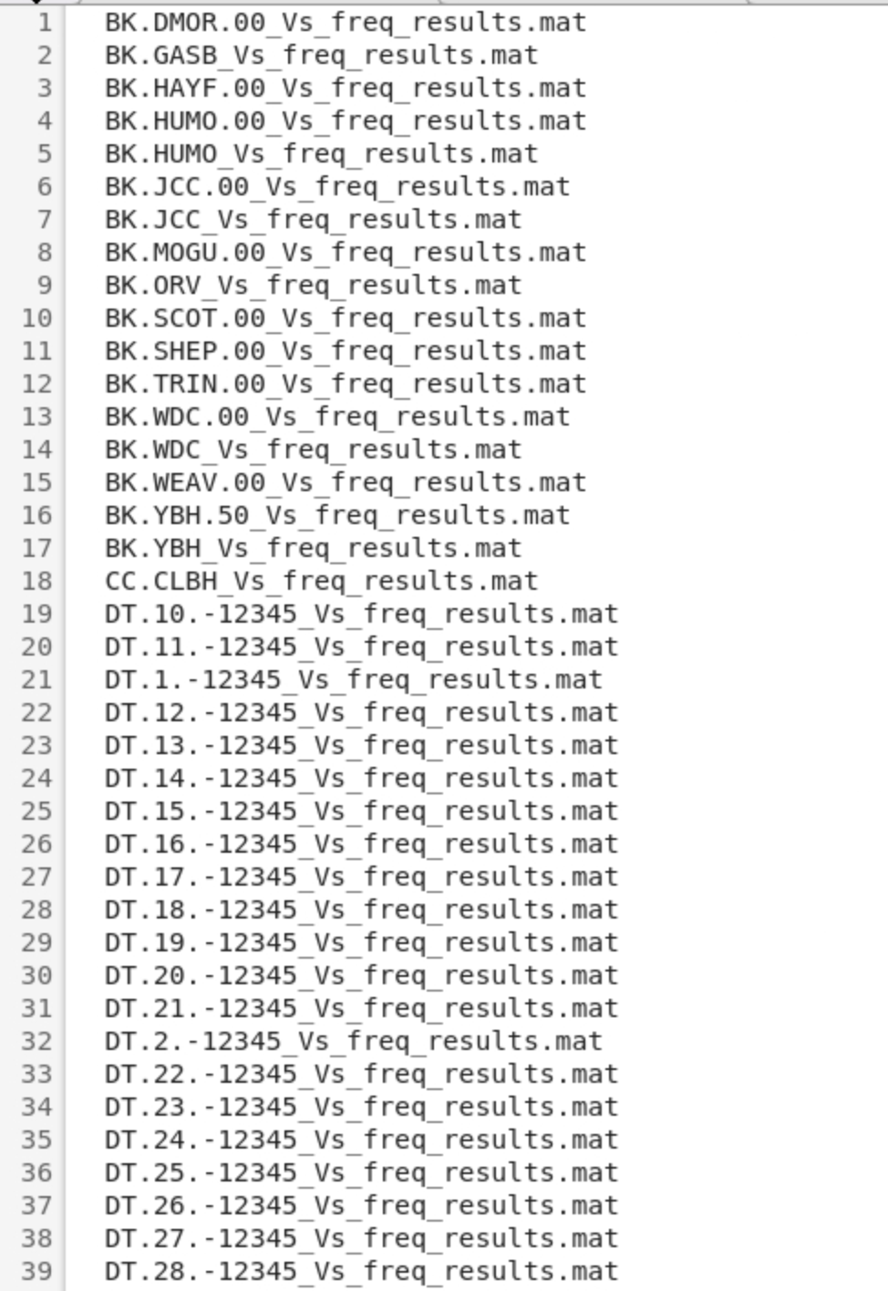

Before running the script, create “RESULTS” and “PLOTS” folder.

Output files: station_topo_results_new.mat. Format: strike, dip, dip-direction

**Step 4: Topographic correction**

Script: Topo_correction.m

This script applies topographic correction to Vs estimates at Step 2.

Create folders for saving results and plots: TOPO_corrections and TOPO_corrections_plots.  
  
Changes to be made:  
Line 14 – path to TEST1.mat

Line 37 – path to outputs from Step 3b

Line 117 – path to outputs from Step 2

**Parameters that can be changed:**

* vel_ratio (Line 10): Vp/Vs ratio. Currently set to 2.
* Line 53 (theta): can play with different incident angles.

Input files: Output files from Step 3b and Step 2. Change path accordingly.

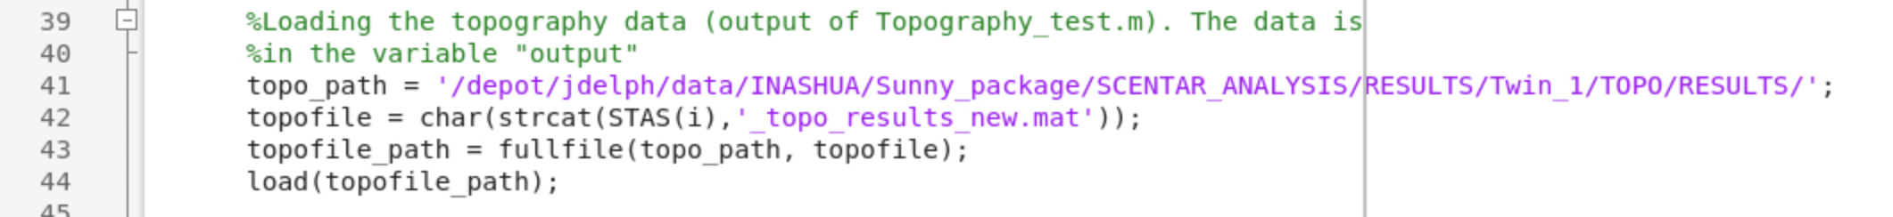

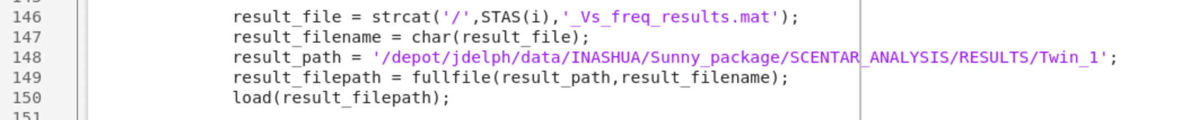



Output files: station_Vs_topo.mat

**Step 5: Calculating depth sensitivities**

Scripts: DepthEst.m

The script calculates depth sensitivities based on the Fresnel zones.

Input files: Output of Step 4

Changes to be made:

Line 5 – path to 2.0_topo_results.txt

Line 12 – path to outputs from Step 4

Line 48 – path to save outputs

Create a text file to read data from

2.0_topo_results.txt:  
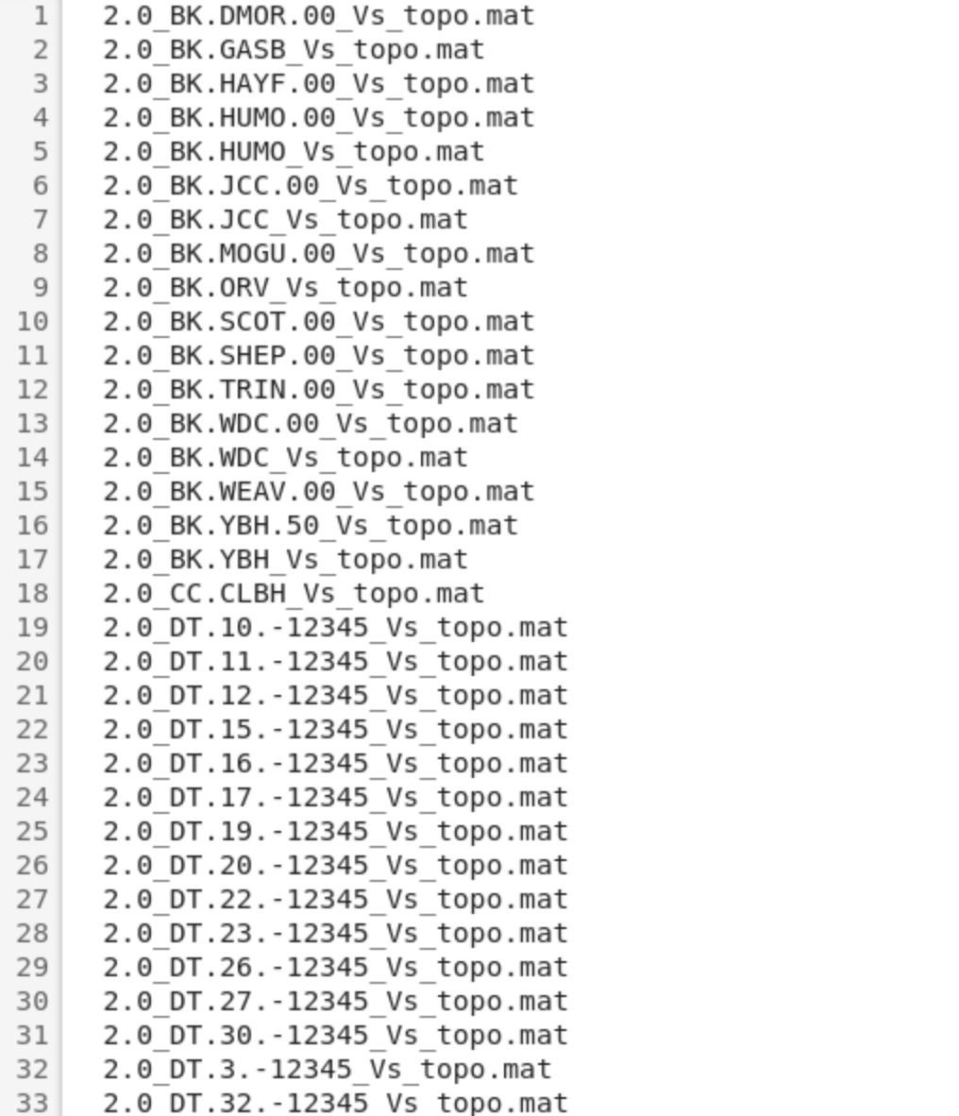

Output files: vel_ratio_station_Vs_notilt_depth.mat.  
Format:  


**Step 6: Statistical test (F-test)**

Script: F_test.mat

This script performs a statistical test (F-test) and outputs the P-value.

Input files: Output of Step 5

Output file: 2.0_P_value.txt – consists of P-values for every station

Create folder to save plots (2.0_STATS_tests). Ensure a list of stations with good data (good_station_list.txt) is available, else create one. No other changes are needed.

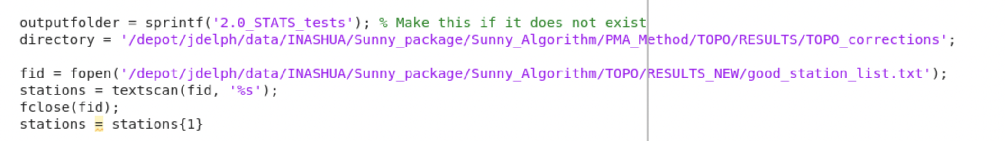

Changes to be made:

Line 5 – path to outputs of Step 5

Line 7 – path to stations list